Exercise 2

Home-Login-Registration-Profile



### **Login Screen :**

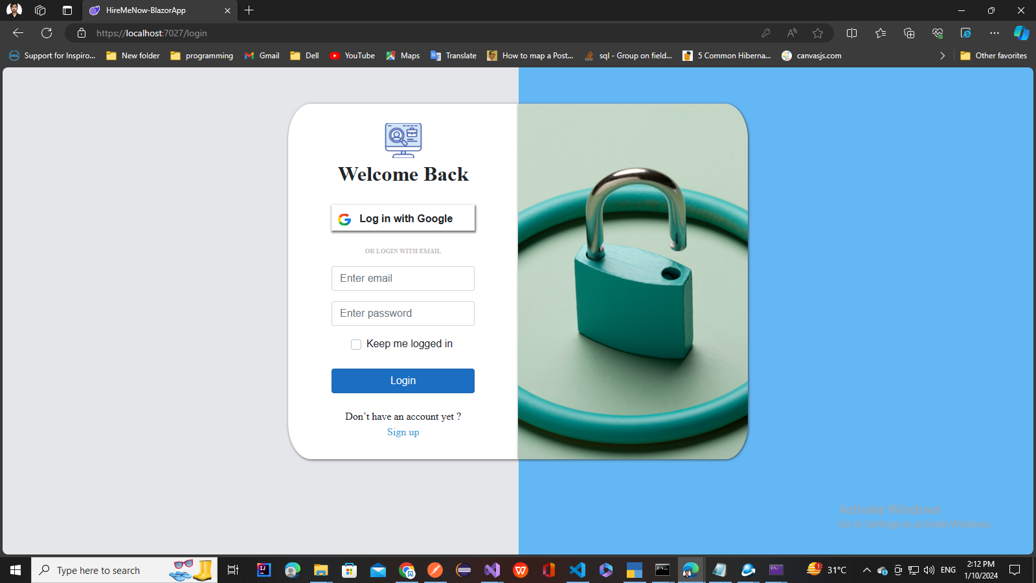

### **Registration Screen :**

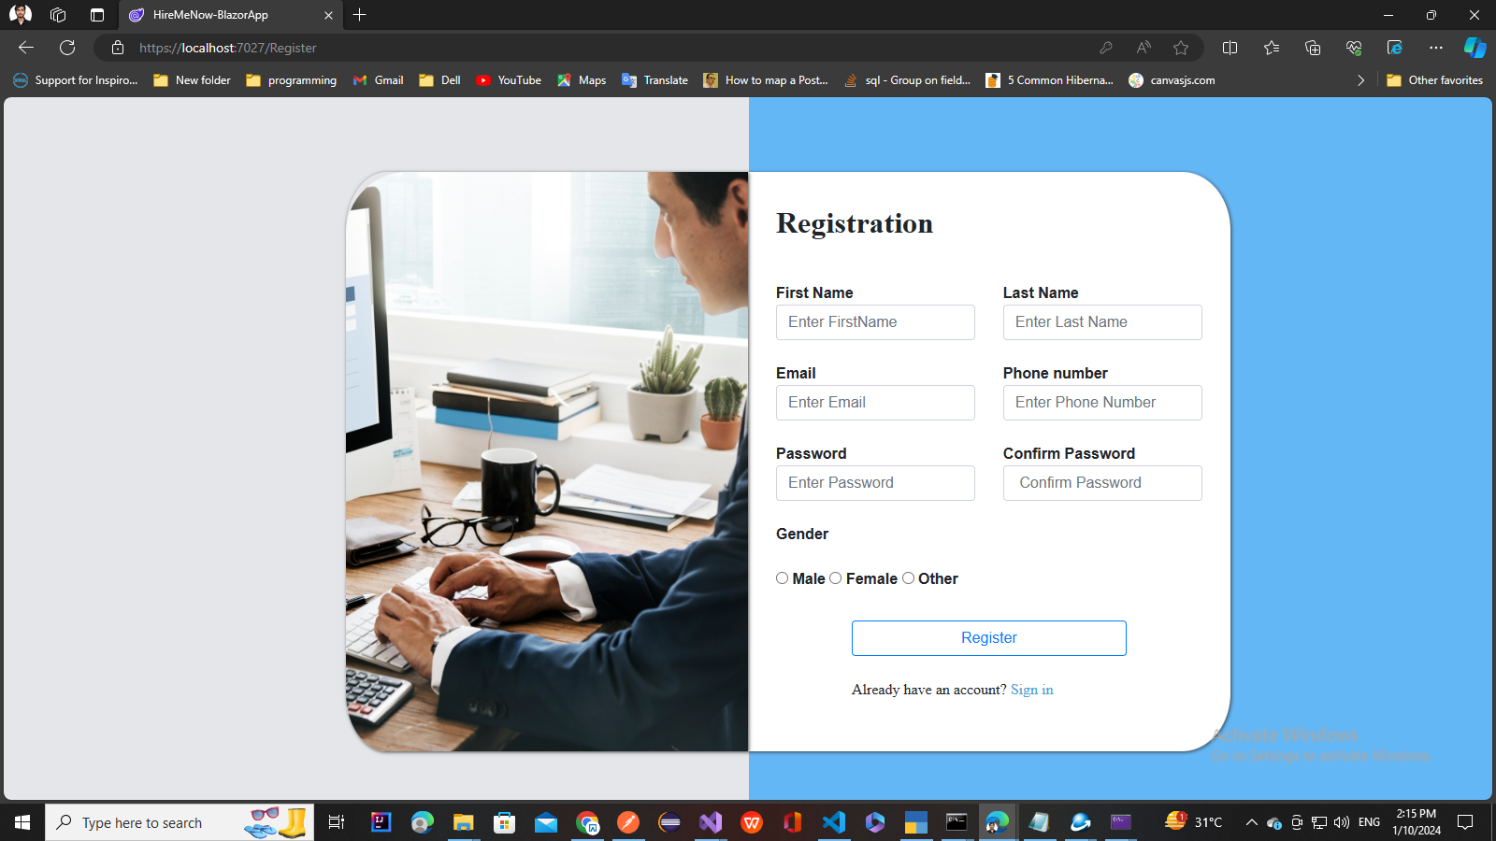

**Profile Page**

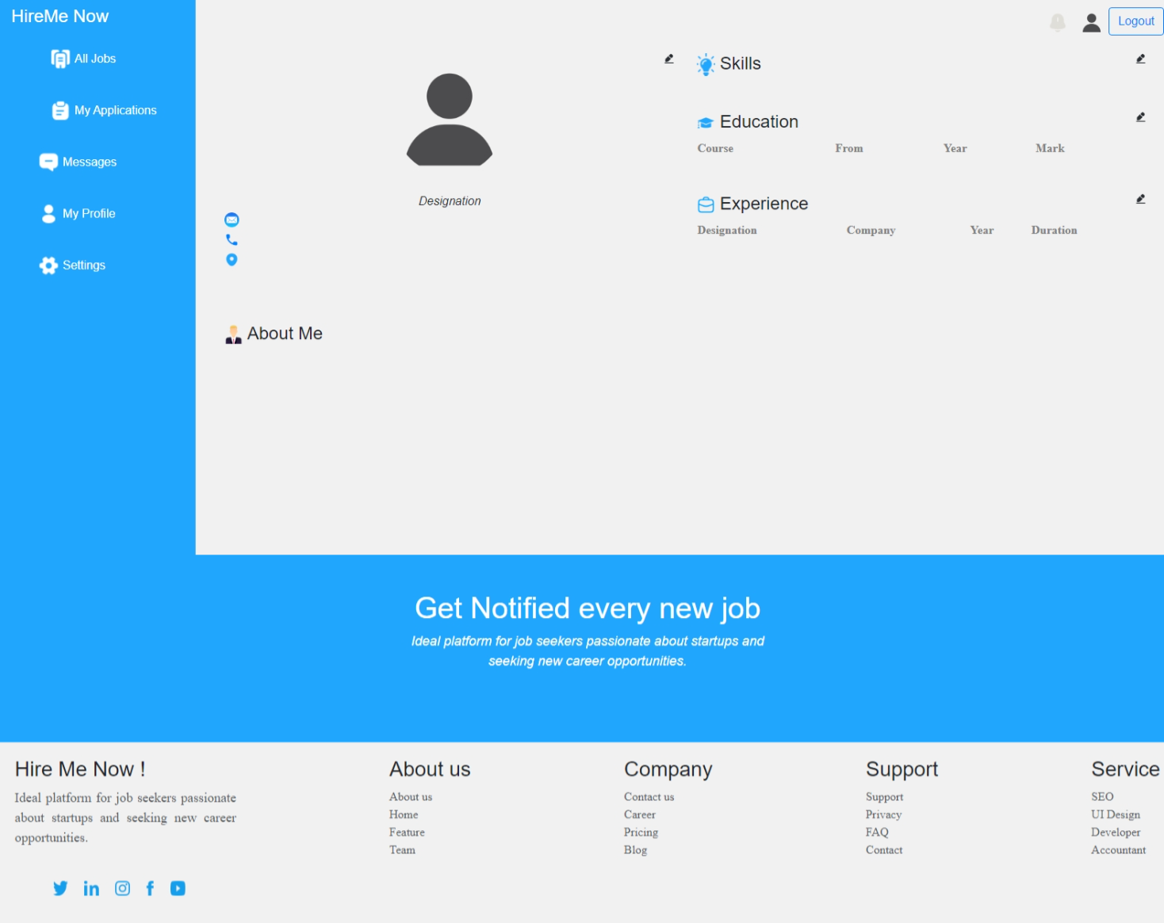

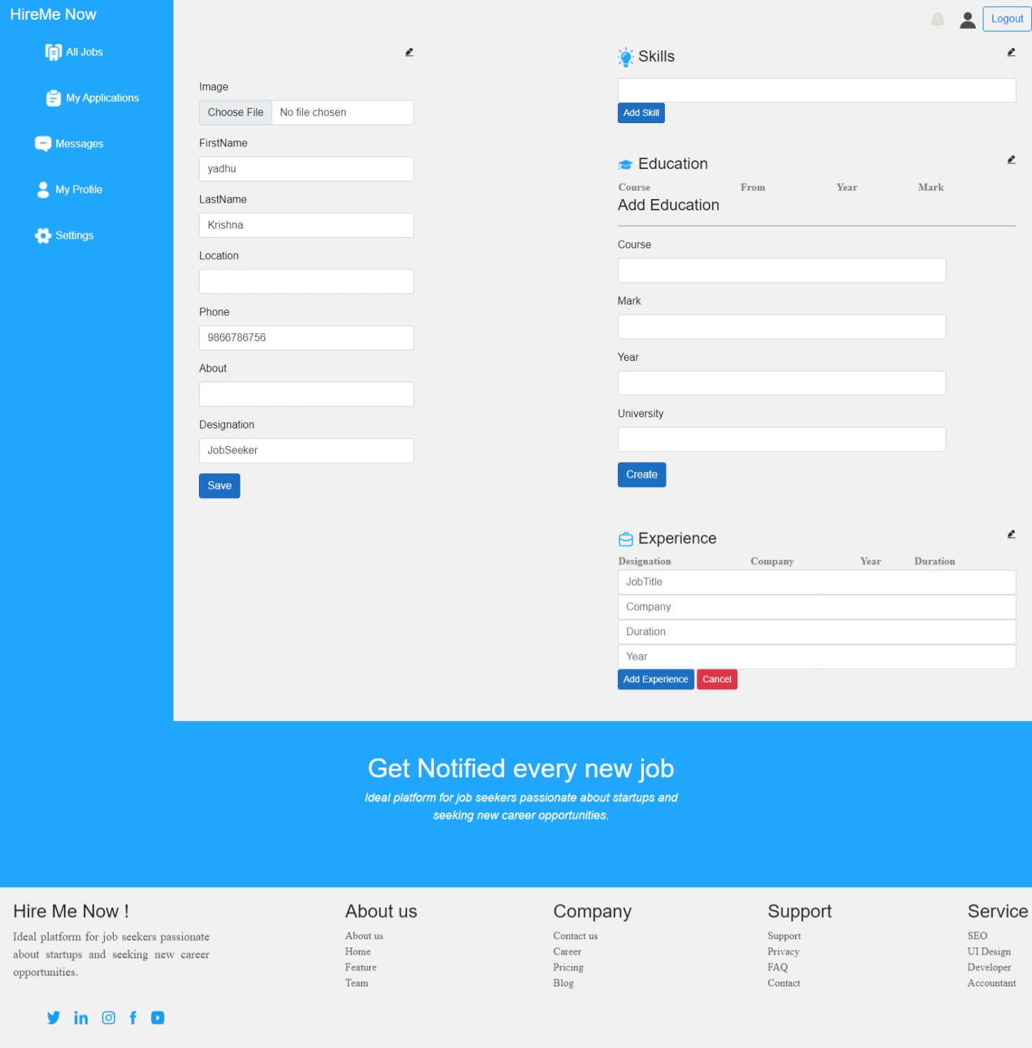

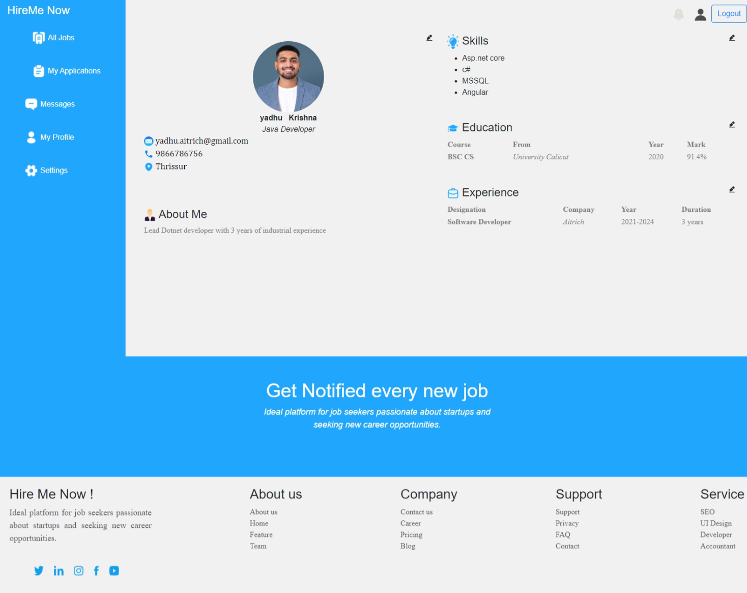

**TODO:**

1. **Design and implement Edit Personal Info**
2. **Design and implement Add,List,Delete,Update Skill Feature And Bind Data**
3. **Design and implement Add, List,Delete,Update Education Feature And Bind Data**
4. **Design and implement Add,List,Delete,Update Experience Education And Bind Data**

